Examples of data based reports
We have not given you examples for good/bad reports from last term since many will simply copy them. You may do assignments by imitating how similar problems have been solved. But this project is about exploration and discovery. Each of you will come to different conclusions because you have approached an issue from a different perspective. Previous memos have given advice on individual elements of a report, but how does it all come together?
We will present several “professional” reports. We do not have access to internal company reports for confidentiality reasons. The reports we will use are ones prepared by government or not-for-profit agencies for public information.
The first example, which is presented below, is an example of a daily report prepared by the Nova Scotia Department of Finance. Their Daily Stats blog is a summary of data that has been released by Statistics Canada. When applicable, they re-analyze StatsCan data to reflect the situation in Nova Scotia. Their audience is the Nova Scotia business community. Usually, they are not looking at a specific “issue” but giving a descriptive update on some aspect of the Canadian or Nova Scotia economy. They assume that their audience has about 5 minutes to scan the blog to see if there is anything that is relevant to their organization. They use simple charts rather than tables. The highlights of the analysis are shown with bullets rather than paragraphs. The blog is designed for scanning, rather than in depth reading. It usually starts at a very high level and then gets progressively detailed as you scroll down. Some readers will stop when they have the level of detail that they need.
Usually, the report starts off with a line chart showing trends over time. Most often, there is a trend line for Canada (in red) and one for Nova Scotia (in blue).
They then drill down to show data by province. This is usually a column chart. The provinces are organized from east to west. Canada is shown to the far left in red. Nova Scotia is in blue and other provinces are in green.
There may be a breakdown by industry sector or similar area of disaggregation for Nova Scotia. Since the labels have long text, they use a bar chart.
Below is one for Retail Trade that was posted in November 2019.


RETAIL TRADE, JUNE 2019
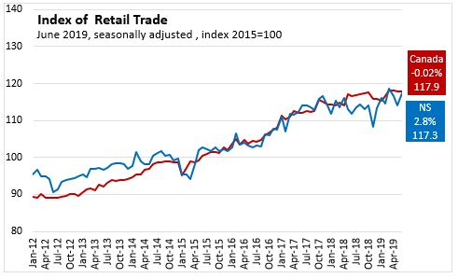
In Nova Scotia June 2019, seasonally adjusted Retail Trade increased 2.8 per cent over May 2019 to $1.4 billion. In Jun 2019 vs Jun 2018, seasonally adjusted Retail Trade increased 4.8 per cent.
Nationally, June 2019, seasonally adjusted Retail Trade was virtually unchanged (declined $8.9 million) over May 2019 to $51.3 billion. In Jun 2019 vs Jun 2018, seasonally adjusted Retail Trade increased 1.0 per cent.

Canada and the Provinces
On a month over month basis, seasonally adjusted Retail Trade was virtually unchanged (declined $8.9 million) nationally. Six provinces reported monthly increases in retail trade, with Prince Edward Island (3.0 per cent) reporting the largest gain. Nova Scotia reported an increase (2.8 per cent) over the previous month. Saskatchewan reported the largest decline (2.7 per cent).

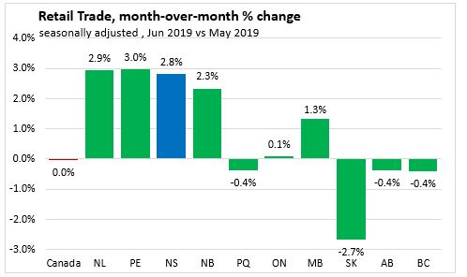
On a year over year basis, seasonally adjusted Retail Trade increased 1.0 per cent nationally. Eight provinces reported year-over-year increases in retail trade, with Nova Scotia and New Brunswick (4.8 per cent) reporting the largest gain. Saskatchewan reported the largest decline (3.8 per cent).
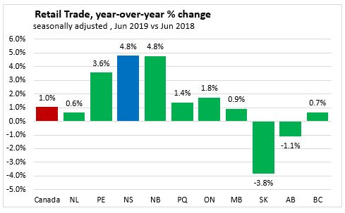
On a year to date basis, seasonally adjusted Retail Trade increased 1.9 per cent nationally. Seven provinces reported year-to-date increases in retail trade, with Ontario (2.9 per cent) reporting the largest gain. Nova Scotia reported an increase (2.3 per cent) over the same period last year. Newfoundland and Labrador reported the largest decline (1.6 per cent).

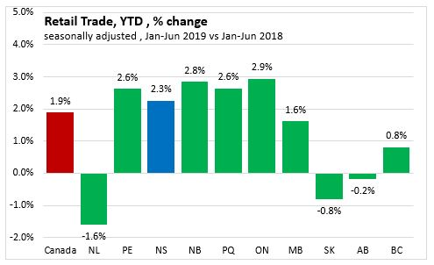
Nova Scotia Sectors
Unadjusted year-to-date (Jan-Jun 2019), Retail Trade increased 2.1 per cent ($158.7 million) over Jan-Jun 2018 to $7.7 billion.
Sector increases:
- Motor Vehicle with a 29% share of Retail Trade increased 5.5 per cent ($116.7 million).
- Furniture with a 2% share increased 0.8 per cent ($1.4 million).
- Food & Beverage with a 22% share increased 5.5 per cent ($89.7 million).
- Sporting & Hobbies with a 1% share increased 1.2 per cent ($1.4 million).
- General Merchandise with a 11% share increased 4.1 per cent ($34.2 million).
- Miscellaneous Stores with a 2% share increased 12.3 per cent ($19.8 million).
Sector declines:
- Electronics with a 1% share decreased 12.7 per cent ($10.1 million).
- Building Material with a 7% share decreased 3.5 per cent ($19.0 million).
- Health with an 8% share decreased 0.3 per cent ($1.9 million).
- Gas Stations with a 12% share decreased 7.0 per cent ($72.5 million).
- Clothing with a 3% share decreased 0.4 per cent ($1.1 million).

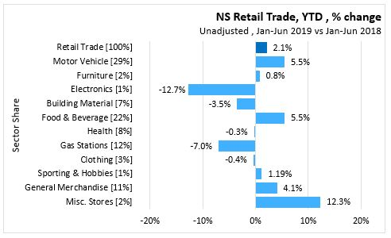
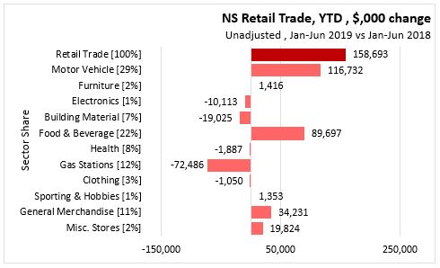

By using similar style in terms of line, column and bar charts, as well as color choice, regular readers can scan and interpret a report very rapidly.
An Example of a Story
Open the file, NOVA SCOTIA ANNUAL POPULATION ESTIMATES AS OF JULY 1, 2019. This was another daily blog, but one that took a much deeper dive into the data and tried to explain how our population has been changing. The graphics are much more complex. Some work well and some are well intended but too complex for the uninformed reader.
Population changes due to births and deaths, among other factors, so their first drill down looked at this aspect.
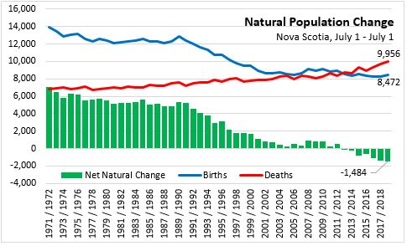
But then there is immigration and emigration, so they then summarized these movements individually and then tried to show the composite picture.
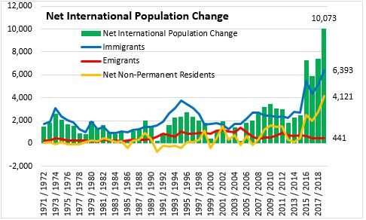
They drilled into looking at movements by age cohort. This is particularly relevant to Nova Scotia since for many decades, our youth have moved to Ontario and Alberta to find work, and then returned for retirement.
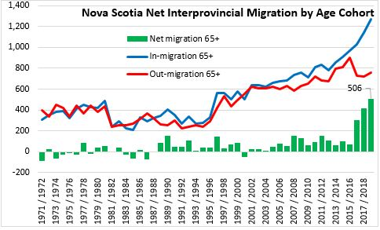
They also looked at net flows by province. These have changed over time,
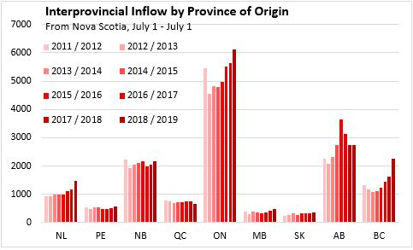
Observe how they have used a combination of line and column charts and an effective use of color.
Their final “story” picture tried to bring this altogether. A very challenging task. Can you understand the graphic below?
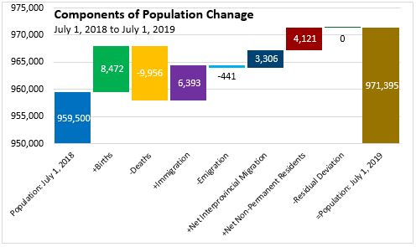
It took me a while to grasp that you must read the chart left to right. Each column tells you how many the movement added or deleted from our population to move us from 959,500 people to 971,395 people in the province. A very ambitious attempt but it fails without someone explaining it.
The report goes on to explore other issues, but I suspect that most readers got no further than this picture.
Throughout the report, only simple charts have been used, but they have drilled deeply into the data. The final slides are unique pieces that you would not get from a pivot chart. They are custom charts designed to tell a complex story. Such charts sometimes work and sometimes they don’t. They are trying to convey complex patterns in a simplistic fashion. Although confusing to a novice reader, they are highly respect by those that have a deep understanding of the data and what the authors are trying to achieve. Remember that you have both novice and expert audiences and presenting something for the experts is appreciated and the novices will pretend they understand.
My compliments to Thomas Storring, Director of Finance for the Province of Nova Scotia, who is responsible for this daily blog. Mr. Storring is also a part time professor at Saint Mary’s, although I have never met him.

Reports with a clear objective
Your report, like most research reports, is not simply a descriptive update on some issue, but an investigation into the issue. The last example was an investigation, but its objective was still descriptive. There was not a central question.

Number and Salaries f Full Time Faculty
The Daily Stats blog from the Department of Finance draws its data from reports that are posted daily on the Statistics Canada web page. Every day, Statistics Canada posts reports on numerous topics. Some reports are descriptive like the Nova Scotia Daily Stats, but many are research reports by staff at StatsCan. Whereas the Daily Stats blog from the NS Department of Finance has a very standard look and feel, Statscan research reports vary depending upon the researchers preparing the report.
The NS trade blog described above alerted me to a new StatsCan study on faculty compensation.
Statistics Canada posts The Daily which highlights data sets and research. On November 25, 2019, when the trade data above appeared, the NS Daily Stats posted a link to the StatsCan The Daily article about faculty salaries. https://www150.statcan.gc.ca/n1/daily-quotidien/191125/dq191125b-eng.htm
This is one of many StatsCan reports on a focused topic. It is noteworthy because of the style used in the report. It is a very short report whose objective is to look at the number and salaries of university faculty, with particular attention to gender differences. In the online story, graphics are presented as small images that you must click on to open, but if you copy the page to a Word document, the charts become part of the document. See StatsCan Daily 25-11-2019 Number and salaries of fulltime faculty.
This report is noteworthy for several reasons. First is the use of section headings to tell the story. The short report has only a handful of paragraphs and each starts with a heading. The headings are:
- Increasing representation of women
- Increasing presence of women as deans
- Growing share of seniors among full-time university teaching workforce
- Shifting structure of full-time academic staff

You can easily see what the themes of the story are. They could have had headings such as, Gender among Faculty, Gender among Deans, Age Patterns among Faculty,… But they chose to make the conclusions the headings. This is very effective when you anticipate that your readers will only scan the text.

Another interesting aspect of this short report was the gender graphic.

Chart 1
Deans and total full-time academic staff, proportion by sex, 1971/1972 to 2018/2019
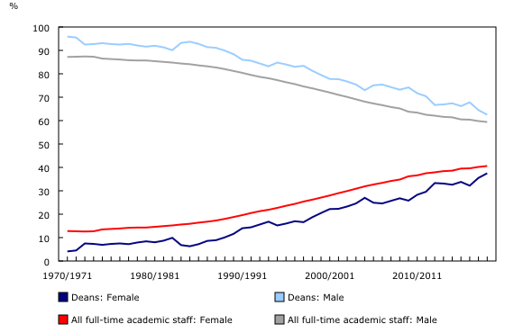
One measure of graphic efficiency is the “ink to knowledge” ratio. In the above case, if I know the % male, I also know the % female. Why do I need two curves? Is the second one not redundant? Yes, it is. But if the story is that the proportion of female faculty (deans) is slowly approaching that of males, then this picture highlights convergence that would not be as obvious if we only had one gender represented. What is the story?

How Much Do They Make

In the reports from NS Department of Finance and Statistics Canada there is no mention of how the data was obtained or “cleaned”. It is collected by means of various surveys and they likely make some adjustments to the data. The reports are frequently very short and they give the reader only what they think is essential. In organizations, many internal reports also do not give significant detail on how the data was obtained or modified (cleaned), but the researcher who writes the report must always be ready to defend the analysis and this means be ready with details on data quality. In a presentation, this may mean having some extra slides ready for the Q&A after the presentation. For written reports, this may mean having an appendix available. If you are not ready to defend data quality, you can lose the confidence and respect of your audience.

Reports prepared by academics, public interest groups and other researchers, usually make clear statements at the start of the report about where and how the data was obtained. An example of such a report is How Much Do They Make. This report was prepared by the Labour Market Information Council and the Education Policy Research Institute with the assistance of many other organizations. The lead author is Dr. Ross Finnie, from the University of Ottawa, one of the foremost researchers of post-secondary students in Canada.

The paper examines the early career earnings of Canadian post-secondary graduates, focusing on differences by credential type/level, field of study, gender and immigration status. It is a novel piece of data analysis in that rather looking at responses to surveys of graduates, they merged Statistics Canada data on every post-secondary graduate from 2010 to 2014 with tax records from the Canada Revenue Agency from 2011 to 2015. We have seen how we can have serious data quality problems with surveys. So this is a great leap forward because we now have “official” statistics on everyone (or do we?).

Let us look at the report from problem statement to conclusion.

Problem Statement
Although the initial problem statement was in the title, the introduction becomes more vague. The introduction is only two pages and it does give the basic background. It states “This report identifies the earnings trajectories of graduates by credential and field of study.” “Trajectories” are not defined. They are looking at how earnings change year by year after graduation. Although not mentioned in the introduction, they drill into differences by gender and compare domestic and international graduates.

The topic is extremely important for any discussion on the value of post-secondary education. The authors could have spent a few more words make a compelling case why the research is so important and why you should read the report.

Section 2.0 of the report discusses previous research on this topic. This is common in an academic report, but is not frequently included in typical data analysis reports for industry.

Data Selection and Quality
Section 3.0 is an important section to go through. They discuss the data and their approach at length. In particular, they discuss their data sources and their limitations. Even though better than survey data, there are limitations associated with their data sets.

Their database is really a data platform that links data from several databases. These databases are described on pages 11 and 12 and then the limitations of the databases and the platform are described on pages 13 and 14. Read these two pages. They are easy to read and you can start to get an appreciation of what we mean when we speak of data limitations. Their problem is not so much with data “quality” in the sense of data errors, but that we may not be measuring what we would really like to know. Like your project, you have to work with what you have rather than what you would like to have.

The next few pages of the report more clearly define what is meant by “earnings”, “credential” and “field of study”. Again, we must understand what our variables are measuring and what they are not.

On page 18 they have a section on “Sample Selection”. Why? Haven’t they already described the data? No. They have excluded various groups of graduates for various reasons. Recall in assignment 3 where we wanted to look at high school average and first term GPA. We excluded a large portion of the original database because there were some sub-populations for which we did not have data or the data may not be applicable.

Before getting into their analysis, they give us a snapshot of who was in the sample. This is useful for convincing the reader that the research is based upon a substantial and diverse data set. Despite them having excluded some graduates, they should be able to make definitive generalizations about post-secondary graduate earnings.

Analysis

In the analysis, they have primarily used simple charts, such as
- Line charts for time series (page 27)
- Column charts for average earnings after 1 and 5 years (page 28) – annotated to show percentage growth
- Box and whisker charts to show diversity in earnings after 1 and 5 years (page 29)

When they drill down to the program level, they note sample size issues (page 31)

The pages that follow use the same mix of line, column and box charts for various sub-groups.

Note that their box and whisker charts are different from the ones we used since for “very low” and “very high” that define the ends of the whiskers, they used the 10th and 90th percentiles.

They used a slightly different column chart on page 50 to show the differences in earnings between males and females by field of study after 1 and 5 years. That is a lot to show in one chart.

There is an enormous amount of analysis and comparisons in the report. There are many words – more than most readers will read. They might have only stated the biggest findings and left the reader to find the rest in their charts.

In general, the headings and chart titles are very bland. They could have inserted the major findings in the headings and titles to better engage the reader.

Overall, it reads like an academic article rather than a magazine article. If your audience is “conservative” and “professional” then you may need to write in this fashion, but if you are trying to be persuasive and engaging, it should be spiced up.

Conclusions

Their conclusion section is brief. Nothing is said that hasn’t been said before. It might have been more effective if they had used bullet points or lists.

Note that the report started with an Executive Summary. They wrote for two audiences. The audience that doesn’t like to read too much would have only read the executive summary. Go back and look at it. They use bold face type within paragraphs. They insert highlights in orange bold type for those that will only scan the highlights. A couple graphs would still have been attractive in the summary.

They have built a dashboard that allows you to make your own charts with their data. It is worth going online and taking a look.

https://lmic-cimt.ca/projects/studentoutcomes/

